Nama : Alvin Hong Wardoyono

Nim : 51019001

Screenshot Hasil Quiz Praktikum

Merek G

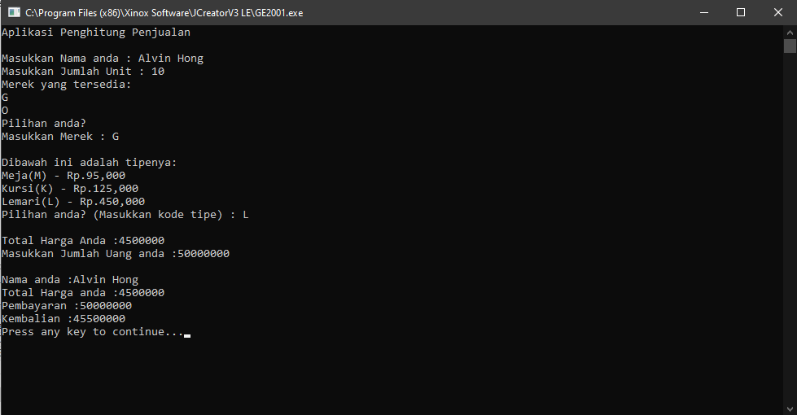

Merek O

